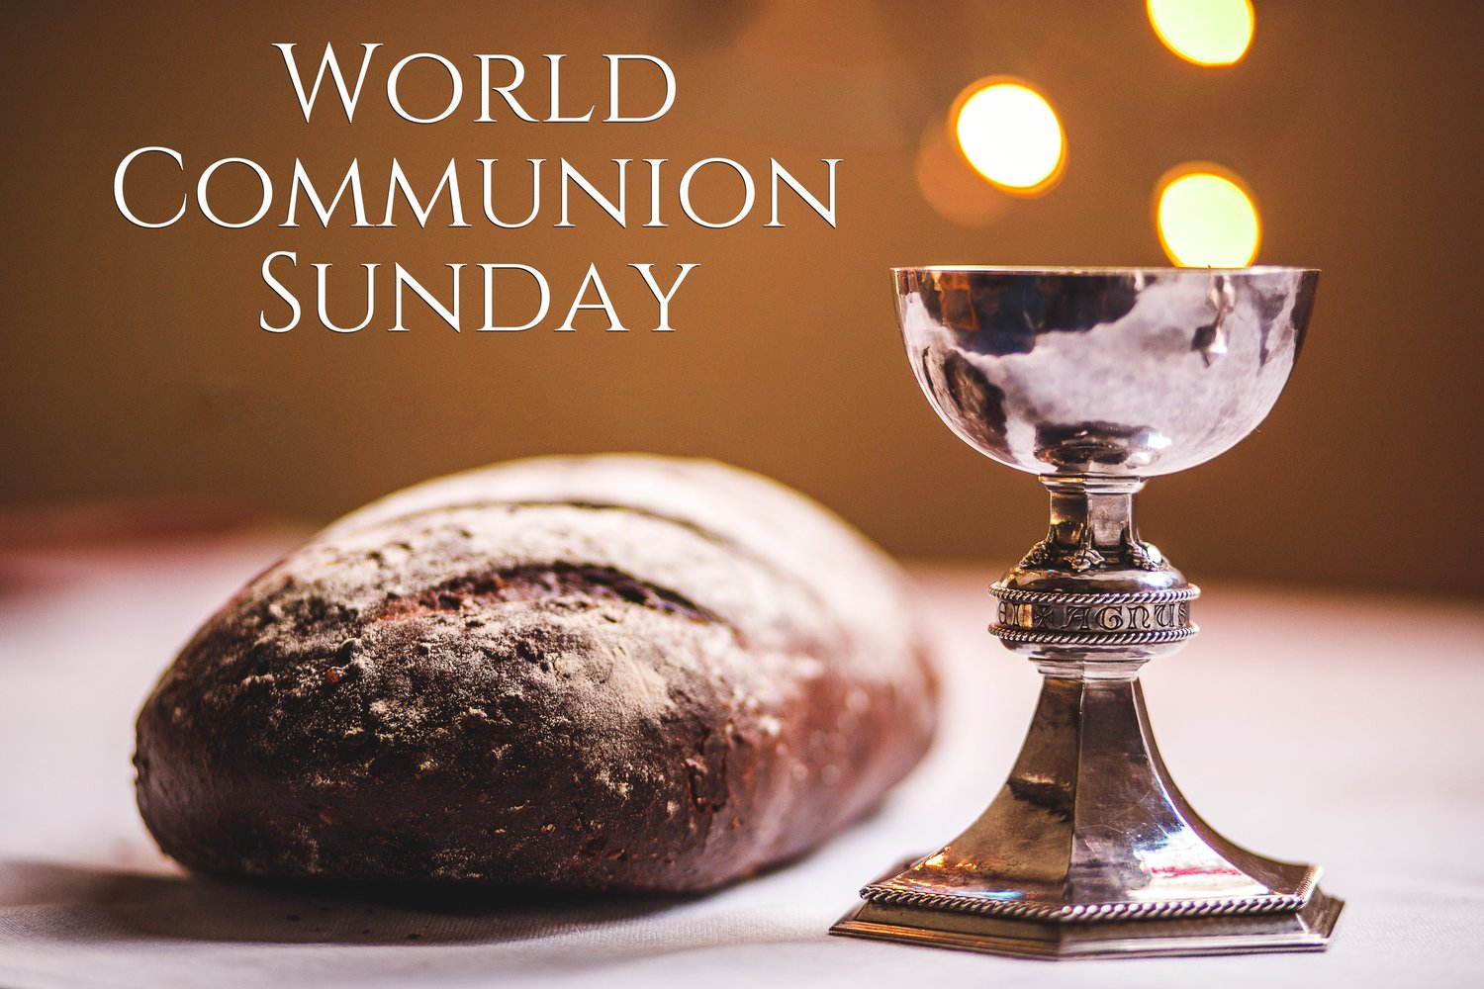

Fifth Avenue Presbyterian Church

301 Patton Avenue NW, Roanoke VA 24016

**Sunday, October 6, 2024**

*Church Phone: 540-342-0264*

***<https://www.5thavepresbychurchroanoke.com>***

**ZOOM ID: 893 2944 7595 PASSCODE: 856037**

**1 Corinthians 11: 17-26**

*17In the following directives I have no praise for you, for your meetings do more harm than good. 18In the first place, I hear that when you come together as a church, there are divisions among you, and to some extent I believe it.* *19No doubt there have to be differences among you to show which of you have God’s approval. 20So then, when you come together, it is not the Lord’s Supper you eat, 21for when you are eating, some of you go ahead with your own private suppers. As a result, one person remains hungry and another gets drunk. 22Don’t you have homes to eat and drink in? Or do you despise the church of God by humiliating those who have nothing? What shall I say to you? Shall I praise you? Certainly not in this matter!*

*23For I received from the Lord what I also passed on to you: The Lord Jesus, on the night he was betrayed, took bread, 24and when he had given thanks, he broke it and said, “This is my body, which is for you; do this in remembrance of me.” 25In the same way, after supper he took the cup, saying, “This cup is the new covenant in my blood; do this, whenever you drink it, in remembrance of me.” 26For whenever you eat this bread and drink this cup, you proclaim the Lord’s death until he comes.*

**2 CENTS a MEAL Offering & FOOD Offering… TODAY October 6**

**JOIN US**: Pray for everyone affected by Hurricane Helene. To support our response, designate gifts to DR000169, send checks to **Presbytery of the Peaks, PO Box 2519, Forest VA 24551** or use this link: [**https://pda.pcusa.org/**](https://pda.pcusa.org/)

**REMINDER:** **5th Avenue safely and securely accepts gifts of offering and giving through mail, in-person, or our website:** [***www.5thavepresbychurchroanoke.com***](http://www.5thavepresbychurchroanoke.com)

***5th Avenue Lawn Care for 2024 graciously sponsored by Carolyn Coleman in memory of Irene Coleman & family***

Fifth Avenue Presbyterian Church

**Sunday, October 6, 2024**

**\*\*\***

**We Gather**

**Musical Prelude** … Frederick Bolden

**Greetings/Call to Worship** … Brooke Stephens

Let us come to the table of communion, not because we must, but because we may. Let us come, not that we are strong, but that we are needy and let us sit together in humility and thanksgiving rather than in pride or possessiveness. O Lord, let us come to the table of your love, so we may worship and praise your holy name. Thank you, Hallelujah and AMEN.

**We Call Upon the Lord**

**Invitation in Music** … Joe Wilson

**Call to Confession** … Karen Watson

Christ invites us to the table of peace, even as we doubt. Christ invites us to the table of hope, even in our disappointment. Christ invites us to the table joy, even when we disbelieve and turn towards our selfish ways, even as we seek to deny others the opportunity to find their joy. Christ invites us to the table when we pray to change our ways. AMEN

**Silent Confession**

**Assurance of Pardon** … Karen Watson

Jesus told us that he is the bread of life; that whoever comes to him will never be hungry and whoever believes in him will never thirst. Because there is one bread and we are one body, no one who comes to the Lord will be driven away. Let us rejoice in the assurance that when we confess our sins and turn towards the truth of the divine, we are forgiven…

**Prayers of the People** … Karen Watson

**The Lord’s Prayer**

*Our Creator, who art in heaven, hallowed be thy name, the kingdom come, thy will be done, on earth as it is in heaven. Give us this day our daily bread and forgive us our debts as we forgive our debtors. Lead us not into temptation, but deliver us from evil, for thine is the kingdom and the power and the glory forever. AMEN.*

**Gloria Patri** … Frederick Bolden

**Blessed Break** *(Let us greet one another in the name of Jesus)*

**We Share God’s Word**

**Scripture Study** … 1 Corinthians 11: 17-26 … Beth Durodoye

**Reflect in Music** … Rev. Ellen Woodworth

**Sermon** … Over Already? … Rev. Vernie L. Bolden, Jr

**We Respond**

**INVITATION TO THE TABLE**

**Meditation**

**The Bread and Cup** (Let Us Break Bread … Frederick Bolden)

**Prayer of Thanksgiving**

**Affirm Our Faith** (Acts 2: 44-47) ***44****All the believers were together and had everything in common.****45****They sold property and possessions to give to anyone who had need.****46****Every day they continued to meet together in the temple courts. They broke bread in their homes and ate together with glad and sincere hearts,****47****praising God and enjoying the favor of all the people. And the Lord added to their number daily those who were being saved.*

**We Tell the Good News**

**Step Out in Music** … Joyce Bolden

**Benediction** … Rev. Vernie L. Bolden, Jr

**\*\*\***

**Our Prayer List**

**Jon Barton, Rhonda Hale, Jim Slaughter, Thomas Parham,**

**Rev. Terri Cornwell, Joe Loving, Jr, Thom Witting, Gabriela Rangel, Geri Tankersly**

**\*\*\***

**We count it a joy that you shared with us today!**

**May the Lord bless you and keep you,**

**May the face of the Lord shine upon you and be gracious to you,**

**May the Lord turn to you and give you peace…**